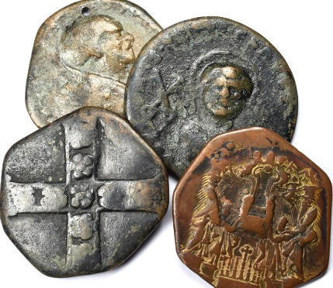
Lot 85 Images Not to scale
19th century Cast religious medals
20-24gr & 35-40gr
£2

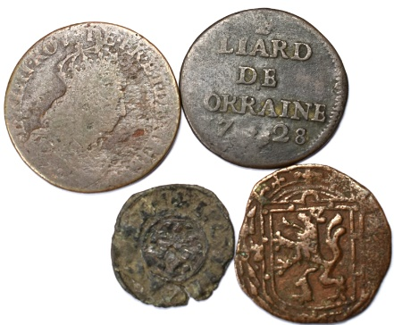
Lot 86
Spanish Netherlands Stevensweert 1626-1632 Duit
1728 France, Leopold I, Liard de Lorraine, Nancy, Copper
1655-1658 Louis XIV 1 Liard very poor
1197-1220 SICILY Frederick II Denier facing eagle /six rayed star fine
£25
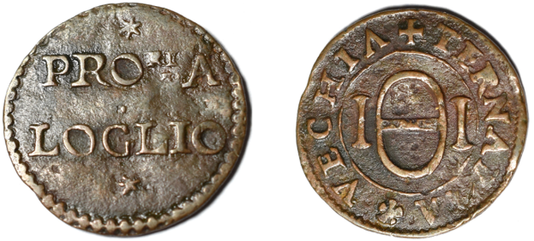
Lot 87
Rationing token for olive oil Venice late 16th Century - 'Ternaria Vecchia - tessera dell'olio' (Voltolina 616) - Obv. PRO RI A LOGLIO / Rev. +TERNARIA * VECHIA around IϴI - copper 21.7-22.5mm, 2.6gr & axis 3hr - VF – rare
£60
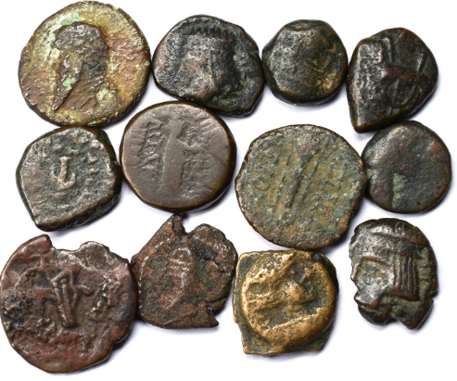
Lot 88
12 PARTHIA AE minors – rev. eagle, horse & double headed 14/9mm £40

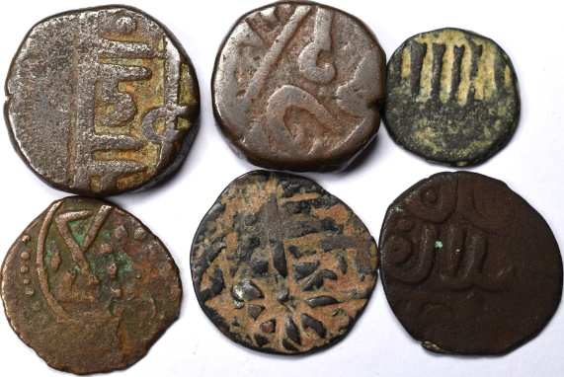
Lot 89

Islamic hammered 5th – 19th century some research x6 20/14mm £6

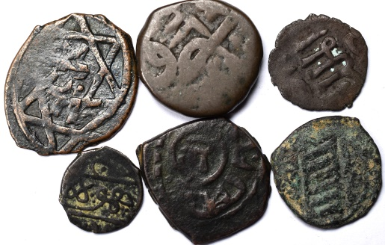
Lot 90
Islamic hammered 5th – 19th century some research x6 24/13mm £6

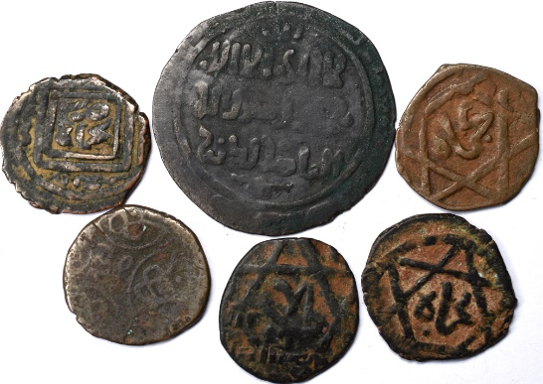
Lot 91

Islamic hammered 5th – 19th century some research x6
32/18mm £6

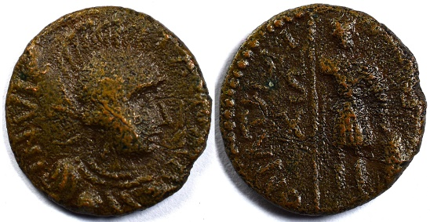
Lot 92

Ostrogoths. Athalaric (AD 526-534). AE decanummium (17mm, 2.4 gm, 5h). Rome. INVIC-TA ROMA, helmeted, draped and cuirassed bust of Roma right / D N ATHAL-RICVS, Athalaric standing facing, head right, spear in right hand, left on grounded shield; S-C across fields, X in left field. BMC Vandals VIII, 25. £80
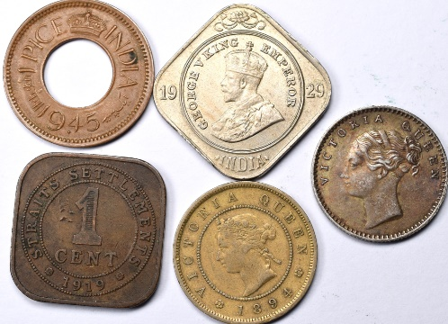
Lot 93
1840 ½ rupee 20 berries VF,
1894 Jamaica Farthing F
1929 2 Annas Calcutta - George V 1929 EF
1945 India 1 Pice High crown; Calcutta
1919 Straits Settlements 1 cent £40
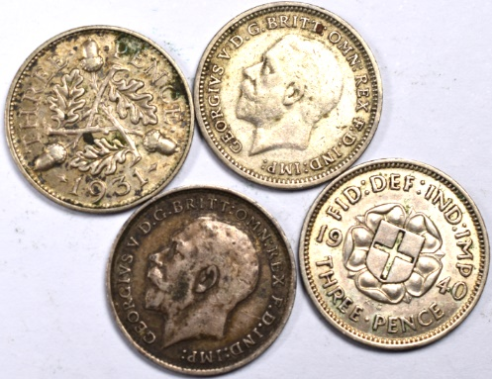
Lot 94
1914 King George V .925 Silver 3d
1931 King George V .500 Silver 3d
1934 King George V .500 Silver 3d
1940 King George VI .500 Silver 3d
£4

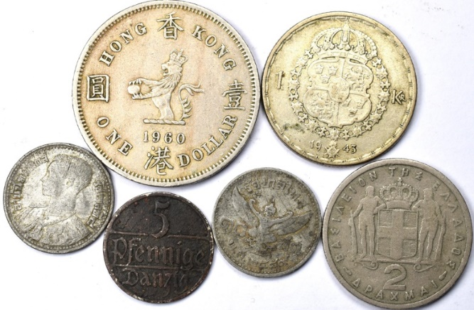
Lot 95
1943 Sweden, Gustaf V, ! Krona, F 0.400 Silver
1954 Greece 2 Drachmai Good
1960 Hong Kong 1 One Dollar Elizabeth II F
Free City of Danzig 1923 5 Pfennig Danzig F
1957 Thailand 25 Satang - Rama IX F
£5
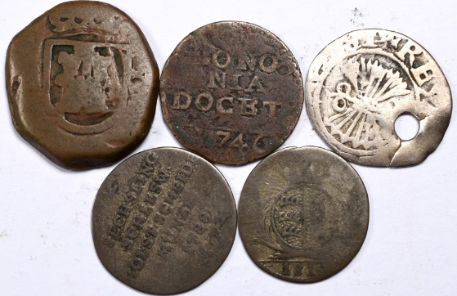
Lot 96
168? Spain - Carlos II 2 maravedís
1746 BOLOGNA Italy Benedetto XIV AE Quattrino
1810 Württemberg (Germany) 6 Kreuzer Friedrich I poor
1788 Schleswig-Holstein, 2 Sechsling MF, Christian VII. von Dänemark poor
½ REAL silver GRANADA Catholic Kings (1474-1504) V Poor holed £5
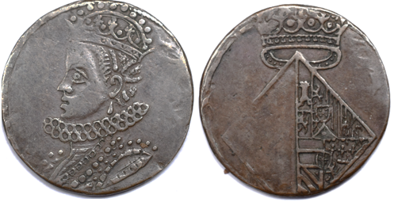
Lot 97
1599 SPANISH NETHERLANDS JETON Albert & Isabella (1598-1621) Bureau des Finances clipped! £5

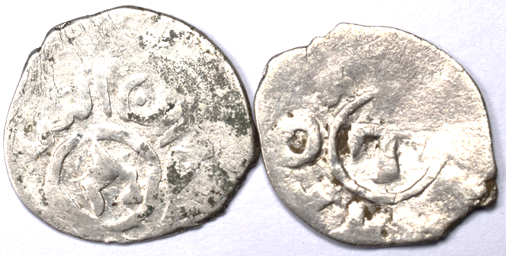
Lot 98
1427-1433 x2 silver Genovese Black Sea colonies Tana. AR Aspro very rare poor
£60

Lot 99
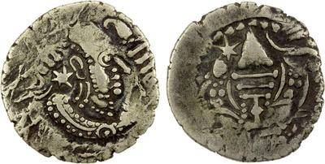
CHAVADAS OF GUJARAT: Anonymous, ca. 760-850, AR drachm 23.6-24.9mm, 4.1gr & 3hr axis £80

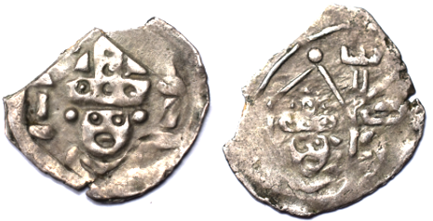
Lot 100
Germany Bishopric of Regensburg Holy Roman Empire 1315 - 1374 1 Pfennig Silver 13.6-17.5mm, 0.6gr & axis 3hr

£10

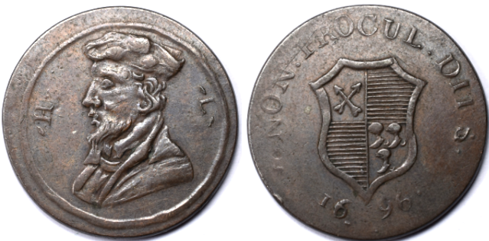
Lot 101

late 18th century - Evasion token 1/2d - HL (Hugh Latimer) 1696 Atkins 398 27mm, 7.7gr & axis 7hr F
£12

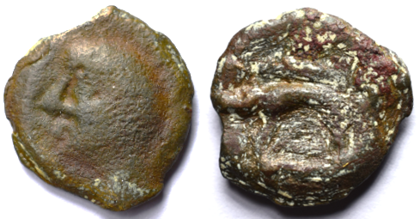
Lot 102
1st century BC Celtic Gaul Leuci Bronze Potin Celtic bust left / Boar with bristles. 17.7-19.2mm, 3.6gr & axis 4hr Better in the hand!
£50

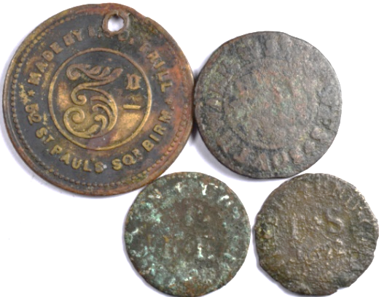
Lot 104
19th century William Martin lion and LAMB COMMERCIAL INN BRENTWOOD ESSEX token 3d by DANIELL
3 unknown 17th century tokens
£4

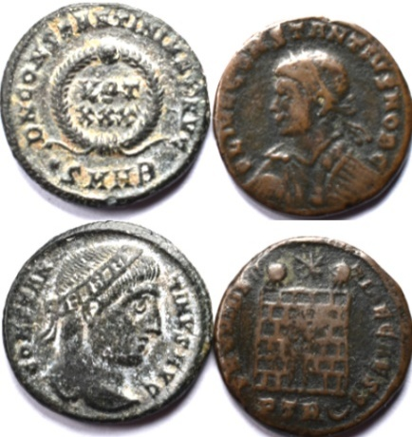
Lot 105
AD 327 Constantine I Heraclea mint VOT XXX in wreath •SMHB in exergue VF
AD 326 Constantius II Treveri (Trier) mint camp gate with two turrets, star above PTR(dot above crescent) F
£5

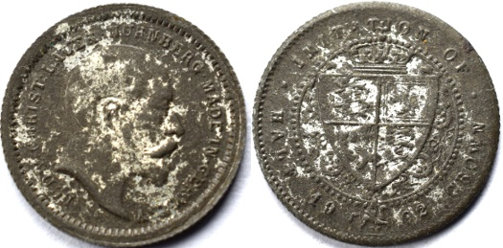
Lot 106
1902 ‘Imitation of half-crown’ toy money Edward VII some loss of plating 12.6mm 0.6gr
£2

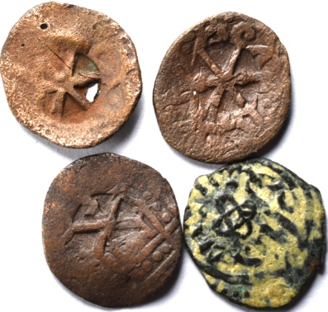
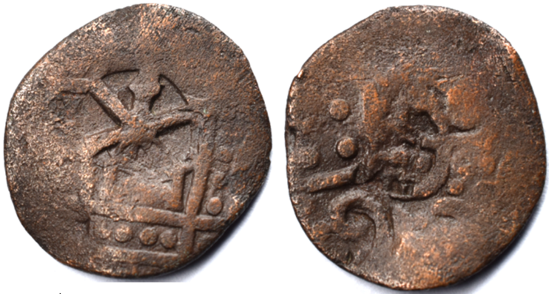
Lot 107

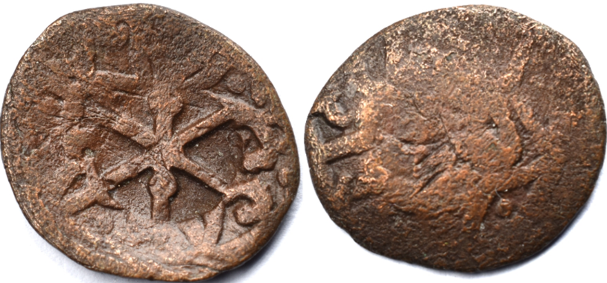

14th century
The Chi-Rho countermark was applied by the Genoese colony of Caffa (modern-day Feodosia in Crimea) during the 14th century (circa 1300–1400 AD). Rare
Rather than minting large quantities of their own copper currency, the Genoese authorities in Caffa preferred to validate and re-tariff the local copper puls minted by the neighbouring Golden Horde. By stamping the coin with this Christian symbol, the city of Caffa officially integrated the foreign Mongol coinage into its own local colonial economy. Another Chi-Rho countermark plus unidentified Islamic coin (4)
17.0-18.1mm, 1.4gr & 16.1-18.0mm, 1.4gr https://en.numista.com/132604
£100

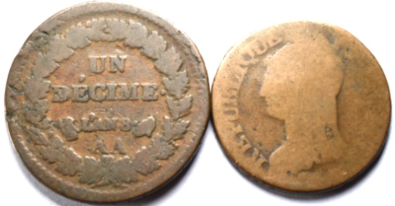
Lot 108
1799 Year 8 France AA (metz) 1799 Un decime poor
Same era Dupré, 5 Centimes very poor
N/R

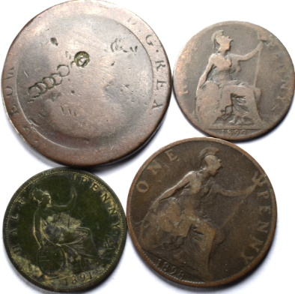
24
Cartwheel penny punch marked very poor
1989 penny poor
1899 farthing poor
1891 farthing poor
N/R

Lot 109
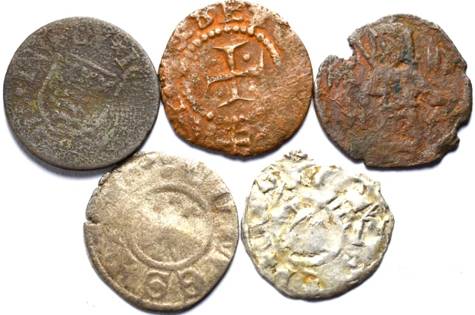
Late medieval x5 all poor or very poor
2 silver 3 base metal one silver unidentifiable? 14.0-16.0mm
£5

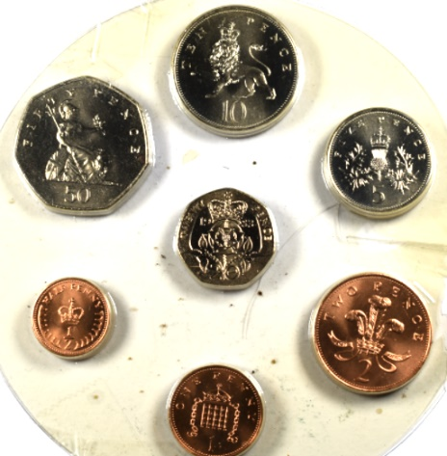
Lot 110
1983 ½ - 50p Unc. set
N/R

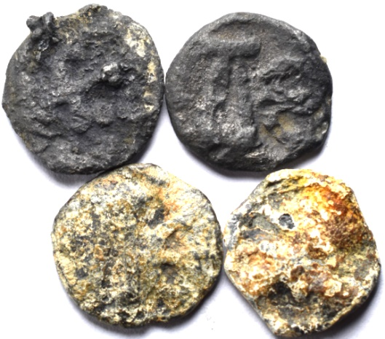
Lot 111
886-912Leo VI the Wise. Æ (15.7-16.9mm, 3.6gr 3h). Cherson mint. Large ΛЄ / Cross crosslet set on two steps; plus another and 2 same era unidentified all very poor
N/R

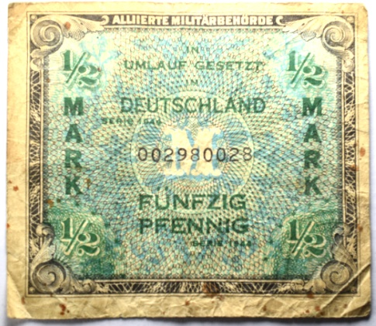
Lot 112
1944 ½ Mark Allied Military Authority French Zone: serial # beginning with "00"
N/R

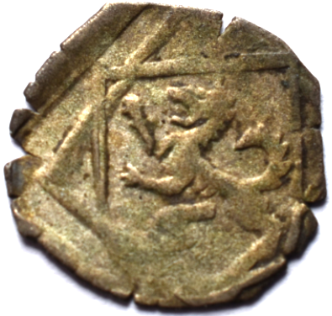
Lot 113
1518-1520 GERMANY 1 Pfennig - Ernest of Bayern 14.4mm, 0.3gr - uniface F
£3

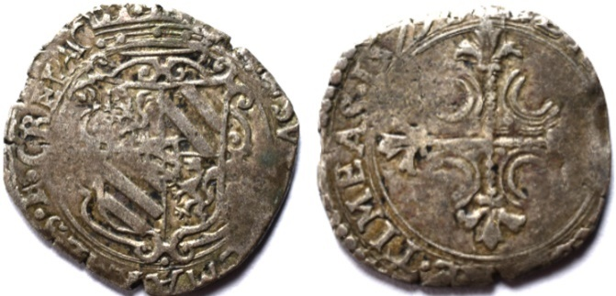
Lot 114
1579 Italy, Piedmont, Messarano – billon Soldo Reverse Ornate cross in circle, date at end of legend [BENE. AGENDO. N]E. TIMEAS. 1579 17.5-19.1 & 1.8gr F
£10

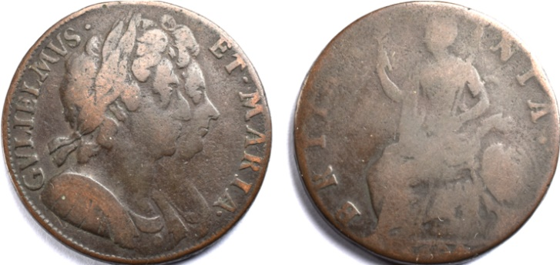
Lot 115
1694? ½ Penny - William and Mary 28.5mm & 10.1gr poor
£2

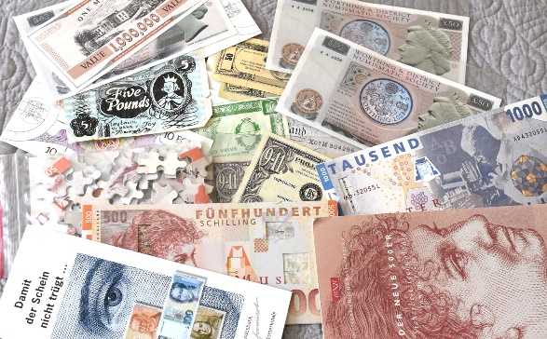
Lot 115
Joke bank notes – lots. Jigsaw & misc. information.
N/R

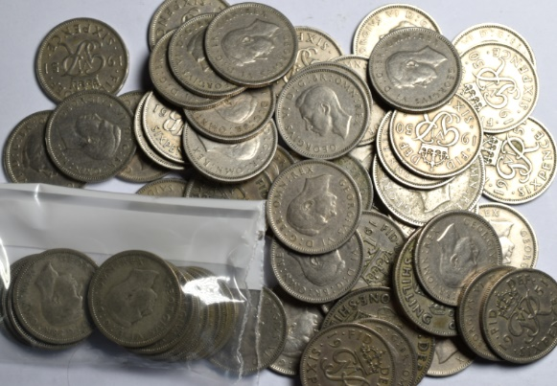
Lot 116
UK 6d x54 George VI. Note - that 11 are 1946 and before Silver (.500) + 4 1948 Scottish 1/- £14

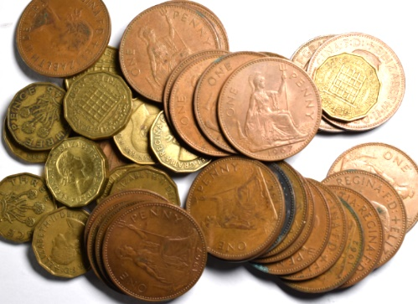
Lot 117
0.4kg pre-decimal copper N/R

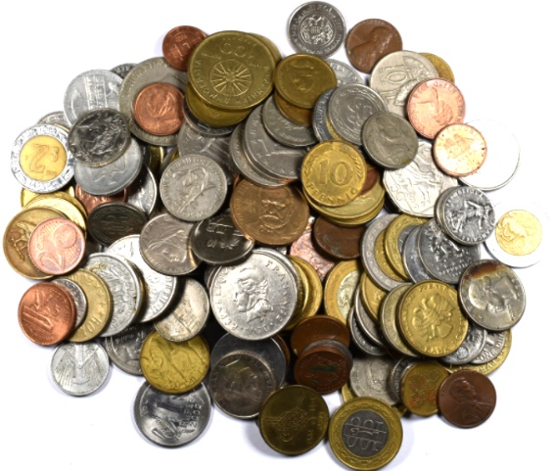
Lot 118
11 0.6kg mixed 20th century world
N/R

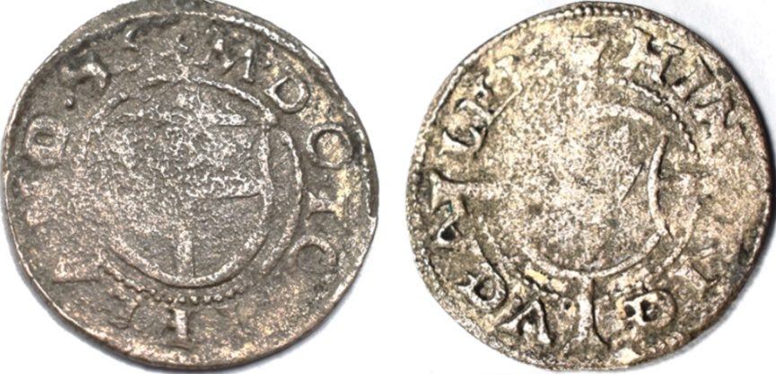
Lot 119

1556 Shilling Latvia and Estonia "Wenden type" Livonian Order Heinrich von Galen (1551-57) Riga Haljak 344 rare 17.6-18.0mm, 1.0gr & axis 11hr Fine
£30

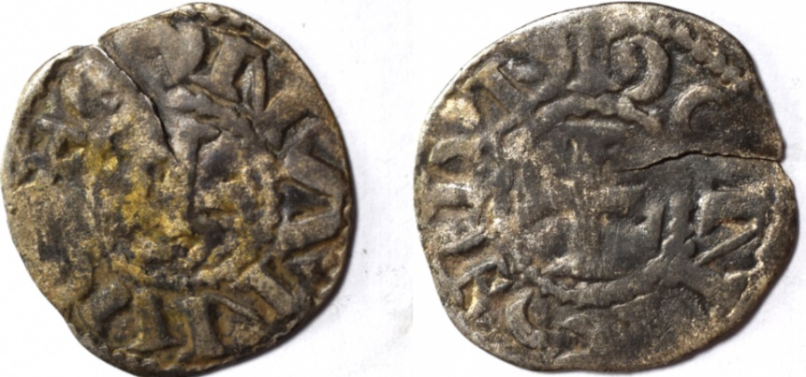
Lot 120

1093-1138 France, Stephen I AR denier (believed) 18.2-19.1mm & 0.7gr Fine £2

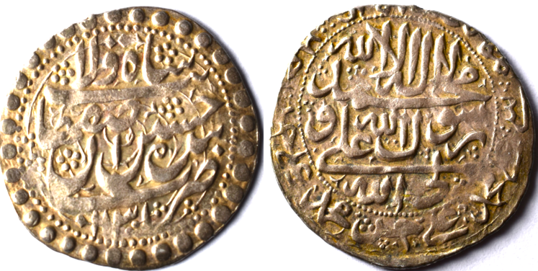
Lot 121
1719 (AH 1132) Shah Sultan Husayn AR Abbasi from Isfahan, Persia (modern Iran) 27.mm & 5.3gr VF
£20

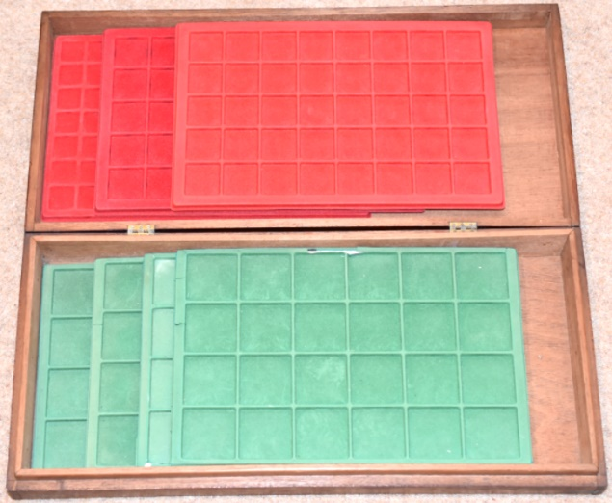
Lot 122
Harwood box 21 ½” by 10” by 3” with 7 ABAFIL trays (2 damaged) N/R

Lot 123
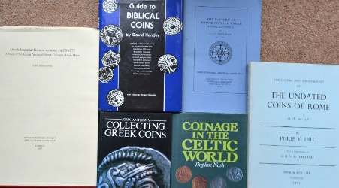
Greek Imperial Denominations, ca 200-275: A Study of the Roman Provincial Bronze Coinages of Asia Minor by Ann Johnston. 2007
The Dating and Arrangement of the Undated Coins of Rome, A.D. 98-148 by Philip V. Hill 1970
Collecting Greek Coins by John Anthony 1983
Coinage in the Celtic World by Daphne Nash. 1987
Guide to Biblical Coins by David Hendin.1987 & The Pattern of Bronze Coinage under Constantine I by J.P.C. Kent.
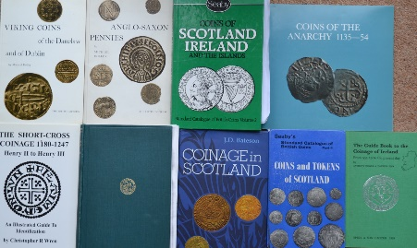
Lot 124
The Short-Cross Coinage, 1180-1247: Henry II to Henry III by Christopher R. Wren. 1992
Viking Coins of the Danelaw and of Dublin by Michael Dolley ex libras 1965
Anglo-Saxon Pennies, written by the numismatist Michael Dolley ex libras 1964
Coins of Scotland, Ireland and the Islands, which is Volume 2 of Seaby's Standard Catalogue of British Coins. ex libras 1984
Coins of the Anarchy 1135–54, written by numismatist George C. Boon 1988
Seaby’s Standard Catalogue of British Coins, Part 4: Coins and Tokens of Scotland Coinage in Scotland by J.D. Bateson 1972
The Guide Book to the Coinage of Ireland from 995 AD to the Present Day by Anthony Dowle 1969
The Scottish Coinage by Ian Stewart, Spink, London, 1955
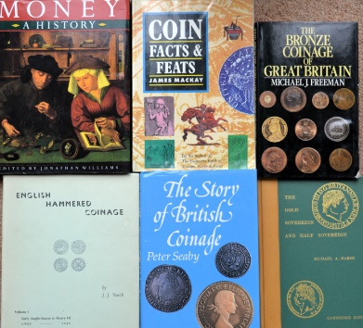
Lot 125
Money: A History, edited by Jonathan Williams 1997
Coin Facts & Feats by James A. Mackay ex libras 1993
The Bronze Coinage of Great Britain by Michael J. Freeman.1985
English Hammered Coinage, Volume 1: Early Anglo-Saxon to Henry III (c. 650–1272) by J.J. North 1963
The Story of British Coinage by Peter Seaby author signed 1985
The Gold Sovereign and Half Sovereign by Michael A. Marsh author signed 1984
Lot 126
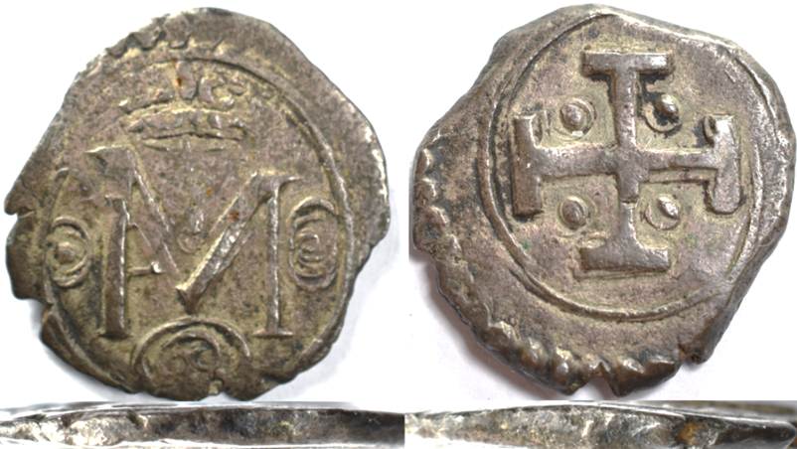
c.1558–60 Scotland — Mary, Queen of Scots / Francis and Mary, Crowned FM monogram obverse, large cross potent reverse with four unusual annular/pellet-like devices. 16.8–18.7mm, 3.0g, 10h.
Not the recognised S.5413 type. The thick flan and reeded edge suggest larger dies, perhaps c.22mm, with a weak or possibly double strike. Possibilities include a contemporary imitation, pattern/experimental piece or medallic issue, though a later fantasy/forgery cannot be excluded. £50

